Civil war in Liberia

UNSC Resolution: | 950
Date of adoption: | 21-Oct-1994
Operative paragraph: | 4
Demand number: | 950,0411

Sarah-Myriam Martin-Brûlé

Wording of demand

cease hostilities immediately and agree to a timetable for disengagement of forces, disarmament and demobilization

List of addressees of the demand

National Patriotic Front of Liberia, Government of Liberia, Lola Defence Force,Liberian Peace Council, United Liberation Movement of Liberia for Democracy - Krahn, United Liberation Movement of Liberia for Democracy - Mandingo

Short-term compliance

Description of the addressee(s)’ conduct

“On 21 December 1994, all factions returned to the Ghanaian capital to sign the Accra agreement. It called for a cease-fire by 28 December 1994, the installation of a new Council of State in two weeks, disarmament within four months, the establishment of safe havens, elections on 14 November 1995, and the installation of an elected government by 1 January 1996. (..) As with previous negotiations, however, problems developed even before the ink was dry. Two days after the schedule date of the cease-fire, fighting continued to rage in the southeast between the NPFL and LPC and in Central Liberia between the NPFL and ULIMO-J.” (Adebajo 2002: 162).
Adebajo, Adekeye. 2002. Liberia’s Civil war: Nigeria, ECOMOG and Regional Security in West Africa. A project for the International Peace Academy. Lynne Rienner Publisher

“Having returned to Accra, on 21 December, the parties signed there two agreements, known collectively as the Accra Agreement. One clarified the Akosombo Agreement, which had been signed by NPFL, Alhaji Kromah's wing of ULIMO and AFL. The other enabled the non-signatories to the Akosombo Agreement -- ULIMO-Johnson, LPC, LDF, the Central Revolutionary Council (CRC-NPFL) and the Liberian National Conference (LNC) -- to accept that Agreement. [CRC-NPFL was a breakaway faction of NPFL.]
(...)
The Accra Agreement stipulated that a ceasefire would come into effect by midnight on 28 December 1994. A new, five-member Council of State would be installed within 14 days thereafter, composed of one member chosen by each of NPFL, ULIMO, AFL/Coalition and LNC and Mr. Tamba Taylor, a traditional chief chosen by NPFL and ULIMO. Elections would be held on 14 November 1995 and a new Government installed on 1 January 1996.
(...)
In the meantime, the Secretary-General informed the Security Council that Mr. Trevor Gordon-Somers would shortly be completing his assignment as Special Representative for Liberia. It was the Secretary-General's intention to appoint Mr. Anthony B. Nyakyi, former Permanent Representative of the United Republic of Tanzania to the United Nations, to succeed Mr. Gordon-Somers. Mr. Nyakyi took up his duties in Monrovia on 28 December 1994.
(...)
The ceasefire came into effect as stipulated in the Accra Agreement. However, the military situation remained highly charged and unstable. Hostilities had spread to over 80 per cent of the country and the fighting had caused massive population displacement. Because of insecurity and serious logistical difficulties, ECOMOG had been deployed in less than 15 per cent of the country. Its absence from major points along the borders was a factor in the continuous breach of the arms embargo.
Liberia,UNOMIL,Background
http://www.un.org/Depts/dpko/dpko/co_mission/unomilFT.htm#DECEMBER

“Although a cease-fire did go into effect on December 28 1994, violations were reported shortly afterward. The Akosombo agreement had failed to address the issue of disarmament and to end the dispute over the composition and chairmanship of the collective Council of State’ Sovereignty over Responsibility.“Deng, Kimaro, Lyon, Rothchild & Zartman 1996: 200)
Deng, Kimaro, Lyons, Rothchild, Zartman. 1996. Sovereignty as Responsibility: Conflict Management in Africa. Brooking Institue.

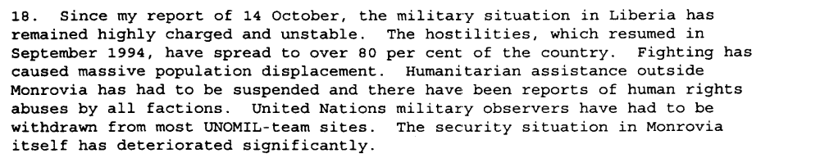
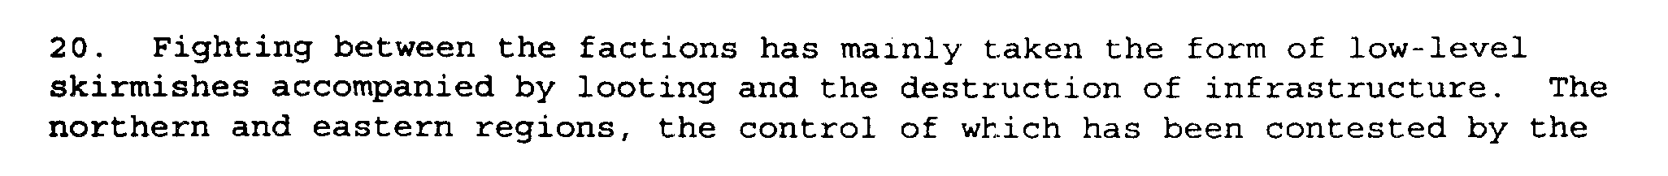
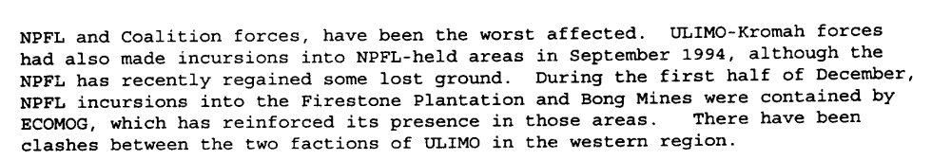
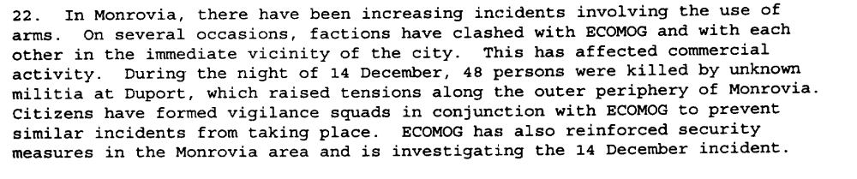
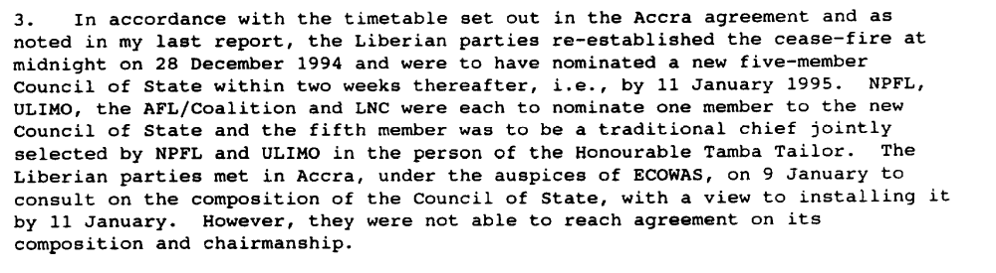
Eighth Progress Report of the Secretary-General on the United Nations Observer Mission in Liberia, S/1995/9, 6 January 1995

“In accordance with the timetable set out in the Accra agreement, the Liberian parties were to have nominated a new five-member Council of State by 11 January 1995. However, when they met in Accra under the auspices of ECOWAS on 9 January, they were unable to reach agreement on the composition and chairmanship of the Council. The main bottleneck was the inability of AFL and Coalition forces (ULIMO-J, LDF, LPC and CRC-NPFL) to reach agreement on their joint nominee. Nominees from the other parties included Mr. Charles Taylor, President of NPFL; Mr. Alhaji Kromah, Chairman of ULIMO-K; and Mr. Oscar Quiah, representative of LNC.”
UNOMIL, Liberia, Background
http://www.un.org/Depts/dpko/dpko/co_mission/unomilFT.htm#DECEMBER

Assessment

Short-term compliance
X No or marginal compliance (1) | Medium low compliance (2) | Medium high compliance (3) | Full or almost full compliance (4)

Considerations underlying the assessment

A cease-fire went into effect two months after the resolution was adopted. Hostilities were not ceased immediately. The demand addressees did not agree on a timetable for disengagement of forces, disarmament and demobilization.

Medium-term compliance

Description of the addressee(s)’ conduct

“Despite four days of discussions and the emergence of a substantial measure of agreement on nearly all the outstanding issues, the Liberian parties were unable to reach a final agreement on the composition of the Council of State.”
(...)
“In the meantime, fighting in Liberia continued between ULIMO-K and ULIMO-J in Grand Cape Mount and Bomi counties; between NPFL and ULIMO-K in Lofa county; between NPFL and ULIMO-J in Bong and Margibi counties; and between NPFL and LPC in Grand Bassa and Maryland counties. Several towns changed hands, and there were reports of human rights abuses as combatants moved into or out of a particular area. All this resulted in a continued influx of displaced persons into the ECOMOG-controlled areas of Buchanan and Kakata. Contending factions continued to block access routes into inhabited areas, resulting in the disruption of the delivery of relief supplies and unnecessary suffering of civilians. Because of the unstable security situation, ECOMOG's deployment remained restricted to the central region and to some areas of the western region. United Nations military observers were co-deployed with ECOMOG in Buchanan, Kakata and Monrovia.”
(...)
“An ECOWAS delegation visited Liberia from 25 to 27 (1995) August to assess the situation on the ground and confirmed that the factions had sent instructions to their forces to lay down arms and observe the ceasefire. In the meantime, UNOMIL and ECOMOG began active preparations for the implementation of the Agreement. The Ceasefire Violations Committee, chaired by UNOMIL and consisting of ECOMOG and representatives of the transitional government and the factions, met in the beginning of September to review with the factions plans for monitoring the ceasefire and the implementation of the other provisions of the Agreement, including disarmament and demobilization. A Disarmament Committee, chaired by ECOMOG and comprising UNOMIL, the transitional government and representatives of the armed factions, with the participation of the International Committee of the Red Cross (ICRC), was established to draw up plans for the disengagement of forces, disarmament and the exchange of prisoners of war. The international community was urgently requested to provide support for ECOMOG as well as for the disarmament, demobilization and reintegration of combatants.”
(...)
“By the end of 1995, following some initial progress in the implementation of the peace agreements and improvement in the security and humanitarian conditions in the country, the situation in Liberia began to take another turn for the worse. The implementation of the Abuja Agreement was behind schedule. The critical aspects of the Agreement, disarmament and demobilization, did not begin at the time foreseen. There were serious violations of the ceasefire. These violations included intermittent fighting between Alhaji Kromah's forces (ULIMO-K) and Roosevelt Johnson's forces (ULIMO-J). Fighting also occurred between LPC and NPFL and between NPFL and ULIMO-K. There were also delays in deploying ECOMOG personnel and equipment throughout the country. At the end of December 1995, heavy fighting broke out at Tubmanburg as a result of attacks on ECOMOG by ULIMO-J troops. Casualties were suffered by the combatants and by the civilian population.”
(...)
“In this volatile atmosphere, following confrontations between rival groups within ULIMO-J, the transitional government, on 23 March, issued a warrant for the arrest of General Roosevelt Johnson, accusing him of murder. On 6 April, the Rapid Reaction Unit of the national police, backed up by the forces of NPFL and ULIMO-K, attempted to arrest him forcibly. They were attacked by General Johnson's forces, supported by fighters from AFL.”
(...)
“The fighting was accompanied by the complete breakdown of law and order in Monrovia. Fighters from all factions systematically looted the commercial district as well as United Nations offices and warehouses. Houses were broken into, buildings were set on fire and vehicles were commandeered.”
UNOMIL, Liberia, Background
http://www.un.org/Depts/dpko/dpko/co_mission/unomilFT.htm#DECEMBER

Assessment

Medium-term compliance
X No or marginal compliance (1) | Medium low compliance (2) | Medium high compliance (3) | Full or almost full compliance (4)

Considerations underlying the assessment

Hostilities continued through the two years following the adoption of the resolution and the parties did not agree to timetable for disengaging, disarming or demobilizing.

Depth of demand

Assessment

Level of depth of demand
Low depth of demand (1) | Medium depth of demand (2) | X High depth of demand (3)

Considerations underlying the assessment

The demand addressees were reluctant to disarm before an interim government would be established. The demand addressees also fear the emergence of new factions which would not be subject to such a timetable.

Level of confidence about coding decisions

Level of confidence about coding decision
Extremely high | X High | Moderate

Comments to IPI (if any)

